# Ritika Kumari- A20414073

# CSP554—Big Data Technologies

## Assignment #13

Exercise 1) (1 point)

Write a command that finds all unicorns having weight less than 500 pounds. Include the code you executed and some sample output as the result of this exercise.

**Command Executed:**

db.unicorns.find({ weight: { $lt: 500 }});

**Screenshots:**

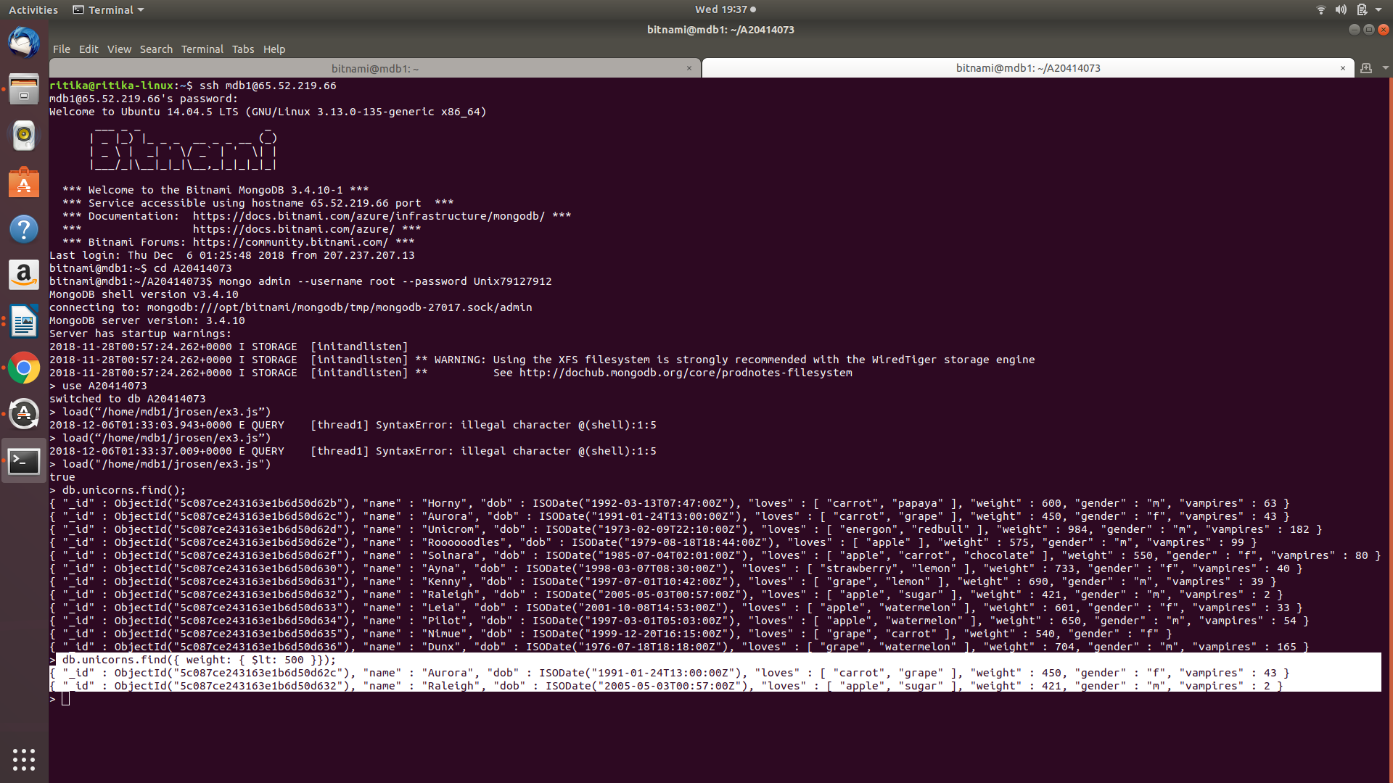

Exercise 2) (1 point)

Write a command that finds all unicorns who love apples. Hint, search for “apple”. Include the code you executed and some sample output as the result of this exercise.

**Command Executed:**

db.unicorns.find({ loves: "apple"});

**Screenshots:**

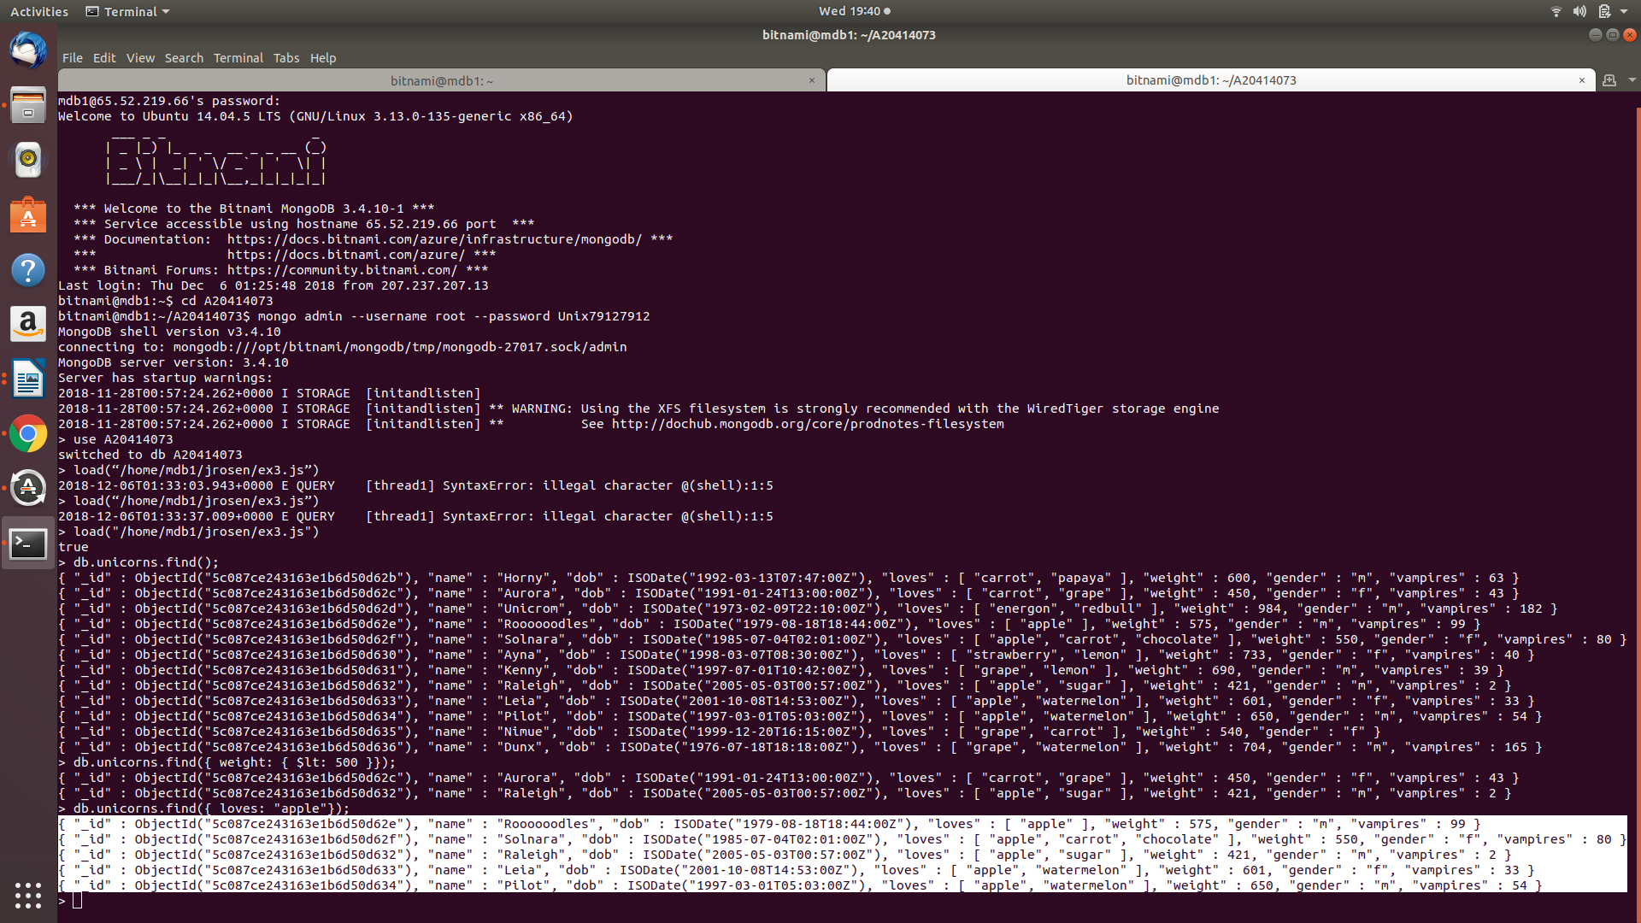

Exercise 3) (1 point)

Write a command that adds a unicorn with the following attributes to the collection. Note dob means “Date of Birth.”

|  |  |
| --- | --- |
| Attribute | Value(s) |
| name | Malini |
| dob | 11/03/2008 |
| loves | Pears and grapes |
| weight | 450 |
| gender | F |
| vampires | 23 |
| horns | 1 |

Include the code you executed to insert this unicorn into the collection along with the output of a find command showing it is in the collection.

**Command Executed:**

db.unicorns.insertOne({name: 'Malini',

dob: new Date(2008, 11, 03),

loves: ['pears', 'grapes'],

weight: 450,

gender: 'f',

vampires: 23,

horns: 1});

db.unicorns.find();

**Screenshots:**

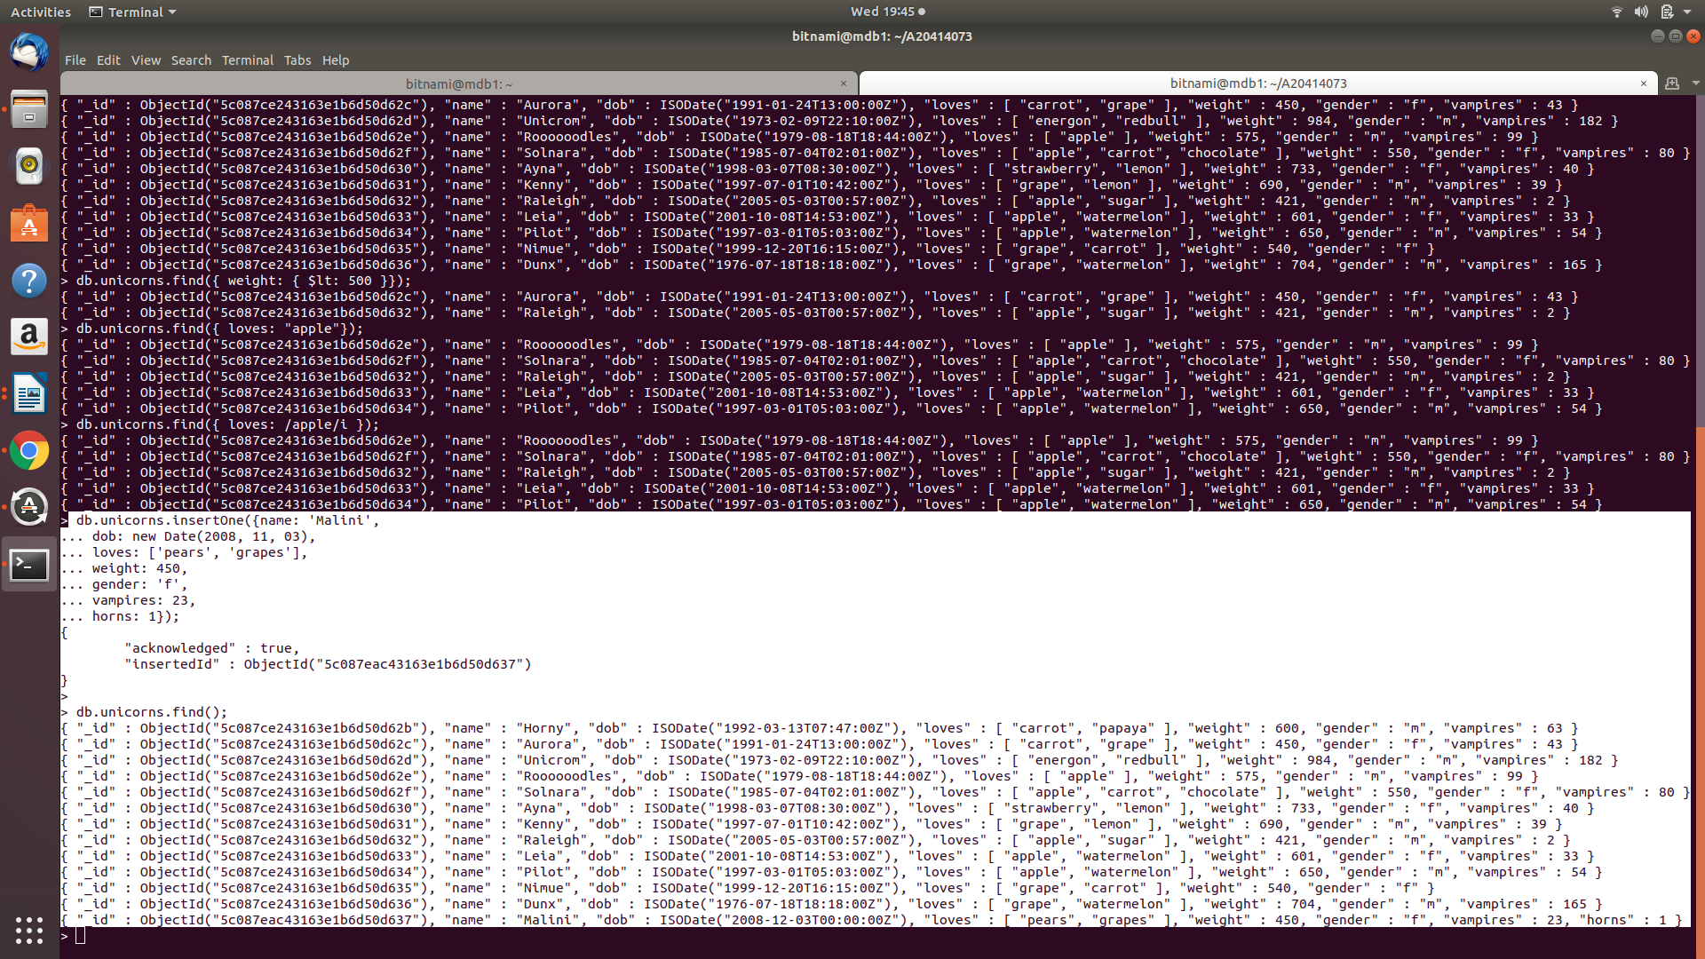

Exercise 4) (1 point)

Write a command that updates the above record to add apricots to the list of things Malini loves. Include the code you executed and some sample output showing the addition.

**Command Executed:**

db.unicorns.updateOne(

{ name: "Malini" },

{ $push: { loves: 'apricots' } }

);

db.unicorns.find({ name: "Malini" });

**Screenshots:**

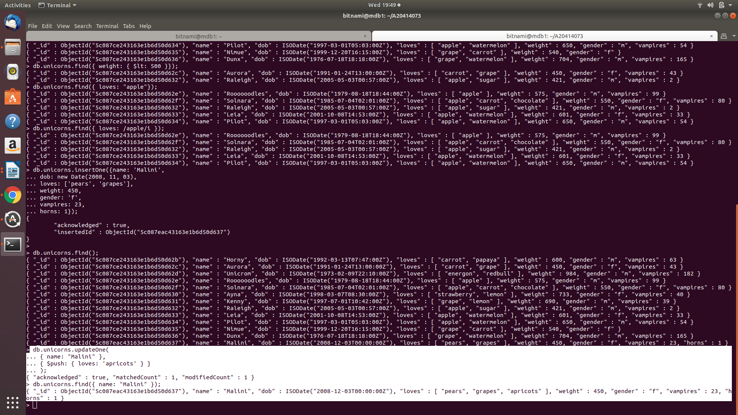

Exercise 5) (1 point)

Write a command that deletes all unicorns with weight more than 600 pounds. Include the code you executed and some sample output as the result of this exercise.

**Command Executed:**

db.unicorns.find();

db.unicorns.deleteMany({ weight: { $gt: 600 }});

db.unicorns.find();

**Screenshots:**

